## Assignment 3

* **Question 1**: what command displays processes as a tree on Linux?

$ pstree

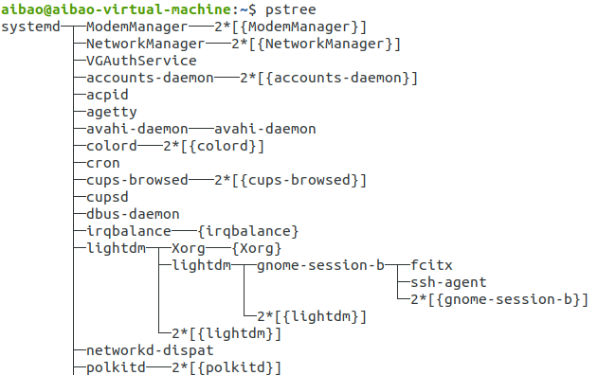

* **Question 2** : what syntax is used on Linux in order to execute a process in the background?

$ nano &

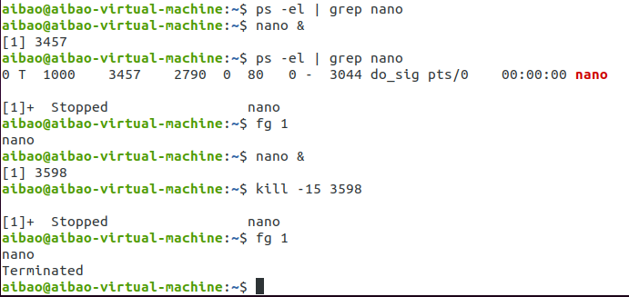

* **Question3** : create a file file1 and write “Hello this is a new file” then get this process *(nano) id*

$ pgrep nano

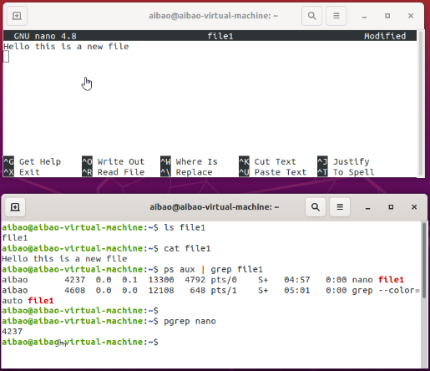

* **Question4** : kill the nano process file 1 from different terminal

$ kill pid

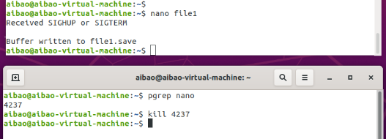

* **Qusetion 5:** write a command to force kill process from different terminal

$ kill -9 pid

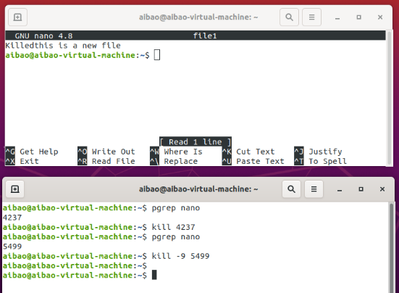

* **Qusetion 6:** write a command to get the parent of a process then kill process from different terminal

$ ps -el | grep nano

$ ps –o ppid PPID

$ kill -9 PPID

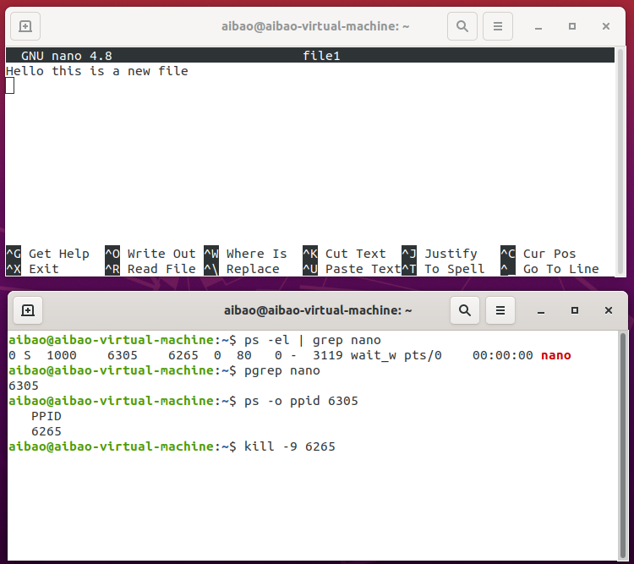

* **Question 7:** Write a c++/Java program that prints this pattern

*****

****

***

**

*

|  |
| --- |
| #include<iostream>  int main(){  int n=5;  int i,j;  for(i=0; i<5; i++) {  for(j=0; j<n-i; j++)  printf("*");  printf("\n");  }  } |

$ g++ triangle.cpp -o triangle

$ ./triangle

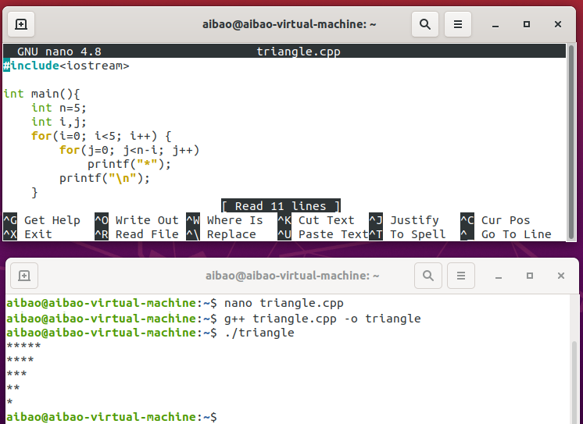

|  |
| --- |
| package work;  import java.util.*;  // Print Star Triangle  public class triangle {  public static void main(String[] args) {  String s="*****";  int len = s.length();  for(int i=0;i<len;i++) {  System.out.println(s.substring(i,len));  }  }  } |

$ javac triangle.java

$ java triangle

